
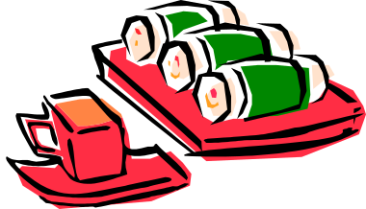

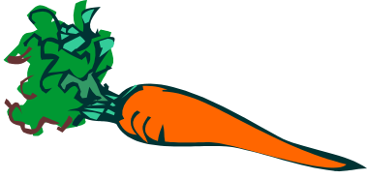

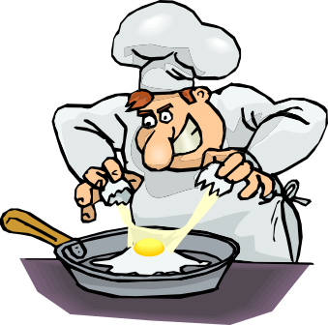

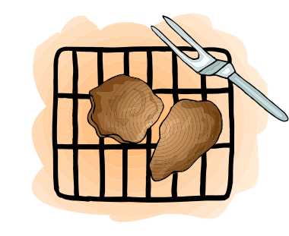
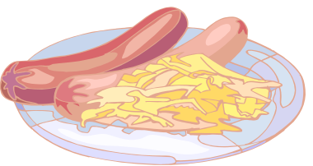

Food
'Supermodel' © Copyright 2001 S & J Shipway
Weight
+1
Health
0
Strawberries
Food
'Supermodel' © Copyright 2001 S & J Shipway
Weight
+1
Health
0
Carrot
Food
'Supermodel' © Copyright 2001 S & J Shipway
Weight
0
Health
-1
Glass of wine
Food
'Supermodel' © Copyright 2001 S & J Shipway
Weight
+1
Health
0
Sushi
Food
'Supermodel' © Copyright 2001 S & J Shipway
Weight
+2
Health
0
Pork Chop
Food
'Supermodel' © Copyright 2001 S & J Shipway
Weight
+2
Health
0
Bangers and mash
Food
'Supermodel' © Copyright 2001 S & J Shipway
Weight
+1
Health
-1
Cocktail
Food
'Supermodel' © Copyright 2001 S & J Shipway
Weight
+4
Health
-2
Big greasy fry-up
Food
'Supermodel' © Copyright 2001 S & J Shipway
Weight
+2
Health
-1
Guinness
Food
'Supermodel' © Copyright 2001 S & J Shipway
Weight
+1
Health
0
Broccoli

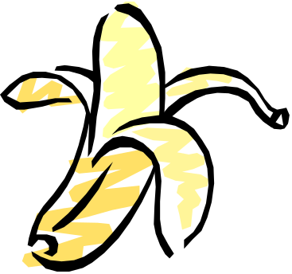



Food
'Supermodel' © Copyright 2001 S & J Shipway
Weight
+3
Health
-1
Chips
Food
'Supermodel' © Copyright 2001 S & J Shipway
Weight
+6
Health
+3
Visit to Auntie Viv’s
Food
'Supermodel' © Copyright 2001 S & J Shipway
Weight
+3
Health
-1
Chocolate cake
Food
'Supermodel' © Copyright 2001 S & J Shipway
Weight
+2
Health
-1
Ice-cream
Food
'Supermodel' © Copyright 2001 S & J Shipway
Weight
+1
Health
0
Banana
Food
'Supermodel' © Copyright 2001 S & J Shipway
Weight
Health

Food
'Supermodel' © Copyright 2001 S & J Shipway
Weight
Health

Food
'Supermodel' © Copyright 2001 S & J Shipway
Weight
Health

Food
'Supermodel' © Copyright 2001 S & J Shipway
Weight
Health

Food
'Supermodel' © Copyright 2001 S & J Shipway
Weight
+6
Health
+3
Visit to Auntie Viv’s

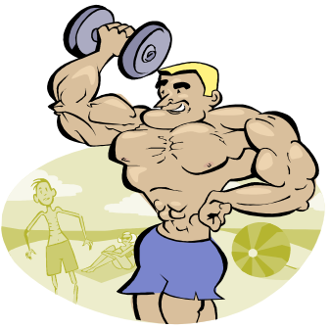
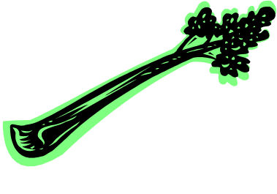
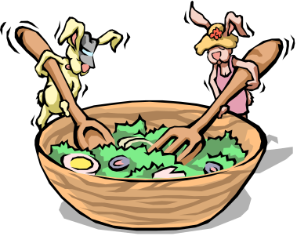
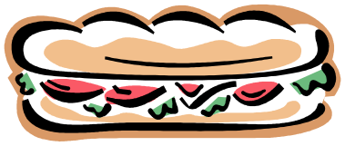
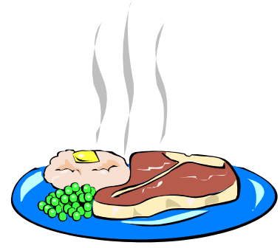
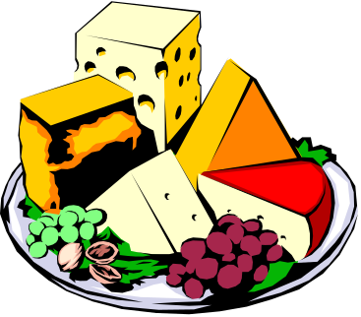
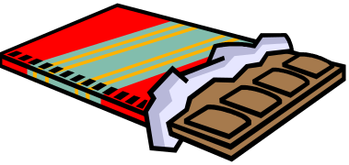
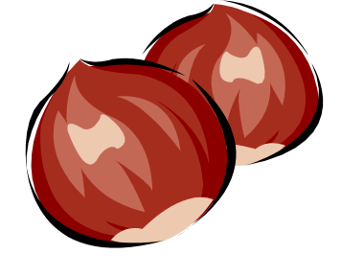

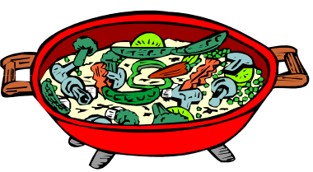
Food
'Supermodel' © Copyright 2001 S & J Shipway
Weight
+1
Health
+1
Spinach
Food
'Supermodel' © Copyright 2001 S & J Shipway
Weight
+1
Health
0
Salad
Food
'Supermodel' © Copyright 2001 S & J Shipway
Weight
0
Health
0
Rice Cake
Food
'Supermodel' © Copyright 2001 S & J Shipway
Weight
0
Health
0
Celery
Food
'Supermodel' © Copyright 2001 S & J Shipway
Weight
+2
Health
0
Nut Roast
Food
'Supermodel' © Copyright 2001 S & J Shipway
Weight
+2
Health
0
Ciabatta Sandwich
Food
'Supermodel' © Copyright 2001 S & J Shipway
Weight
+2
Health
-1
Chocolate Bar
Food
'Supermodel' © Copyright 2001 S & J Shipway
Weight
+2
Health
0
Cheese
Food
'Supermodel' © Copyright 2001 S & J Shipway
Weight
+2
Health
0
Steak
Food
'Supermodel' © Copyright 2001 S & J Shipway
Weight
+2
Health
0
Stir Fry

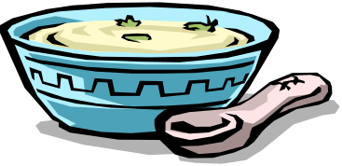

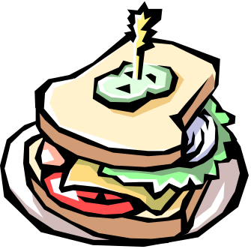
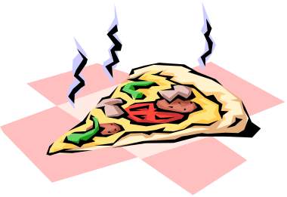

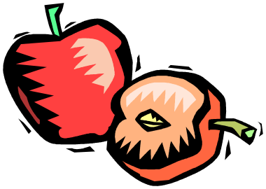

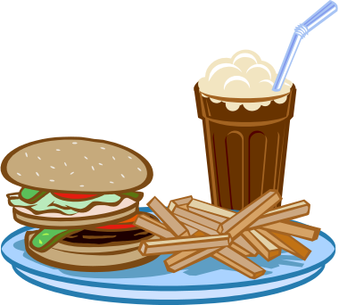

Food
'Supermodel' © Copyright 2001 S & J Shipway
Weight
+1
Health
+1
Pear
Food
'Supermodel' © Copyright 2001 S & J Shipway
Weight
+1
Health
+1
Apple
Food
'Supermodel' © Copyright 2001 S & J Shipway
Weight
+3
Health
-1
Chocolate Eclair
Food
'Supermodel' © Copyright 2001 S & J Shipway
Weight
+4
Health
-1
Burger & Fries
Food
'Supermodel' © Copyright 2001 S & J Shipway
Weight
+1
Health
0
Fish
Food
'Supermodel' © Copyright 2001 S & J Shipway
Weight
+2
Health
0
Pizza
Food
'Supermodel' © Copyright 2001 S & J Shipway
Weight
+1
Health
0
Cheese Sandwich
Food
'Supermodel' © Copyright 2001 S & J Shipway
Weight
+1
Health
0
Milk
Food
'Supermodel' © Copyright 2001 S & J Shipway
Weight
+1
Health
0
Soup
Food
'Supermodel' © Copyright 2001 S & J Shipway
Weight
+3
Health
0
Avocado

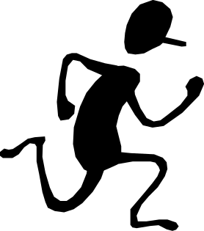


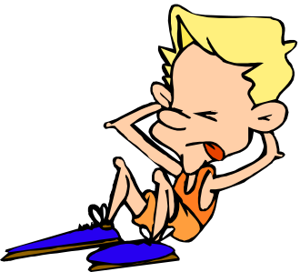


Activity
'Supermodel' © Copyright 2001 S & J Shipway
Weight
-3
Health
-1
Liposuction
Activity
'Supermodel' © Copyright 2001 S & J Shipway
Weight
-1
Health
0
Jiving
Activity
'Supermodel' © Copyright 2001 S & J Shipway
Weight
-1
Health
+1
Exercise Video
Activity
'Supermodel' © Copyright 2001 S & J Shipway
Weight
-1
Health
0
Sit-ups
Activity
'Supermodel' © Copyright 2001 S & J Shipway
Weight
-2
Health
+1
Running
Activity
'Supermodel' © Copyright 2001 S & J Shipway
Weight
-1
Health
+2
Sex
Activity
'Supermodel' © Copyright 2001 S & J Shipway
Weight
-1
Health
0
Discotheque
Activity
'Supermodel' © Copyright 2001 S & J Shipway
Weight
-1
Health
+2
Health Farm Visit
Activity
'Supermodel' © Copyright 2001 S & J Shipway
Weight
-2
Health
+1
Swimming
Activity
'Supermodel' © Copyright 2001 S & J Shipway
Weight
-3
Health
+10
Squash
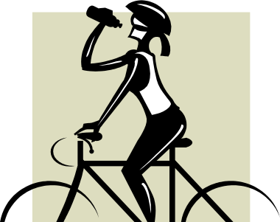
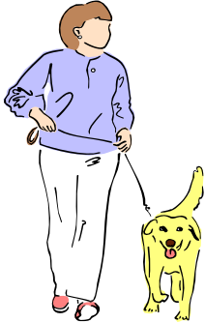
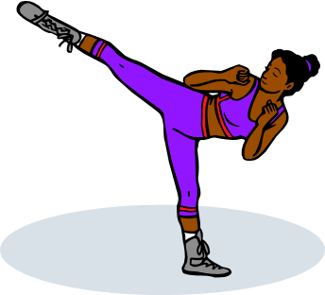
Activity
'Supermodel' © Copyright 2001 S & J Shipway
Weight
-2
Health
+1
Cycle ride
Activity
'Supermodel' © Copyright 2001 S & J Shipway
Weight
-1
Health
0
Country Walk
Activity
'Supermodel' © Copyright 2001 S & J Shipway
Weight
Health
Activity
'Supermodel' © Copyright 2001 S & J Shipway
Weight
-2
Health
+1
Kick-boxing
Activity
'Supermodel' © Copyright 2001 S & J Shipway
Weight
Health
Activity
'Supermodel' © Copyright 2001 S & J Shipway
Weight
Health
Activity
'Supermodel' © Copyright 2001 S & J Shipway
Weight
Health
Activity
'Supermodel' © Copyright 2001 S & J Shipway
Weight
Health
Activity
'Supermodel' © Copyright 2001 S & J Shipway
Weight
Health
Activity
'Supermodel' © Copyright 2001 S & J Shipway
Weight
Health
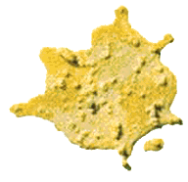
Cancel effect of all Food cards played before this card, this turn.
Chunder!
'Supermodel' © Copyright 2001 S & J Shipway
Health
-1
Cancel effect of all Food cards played before this card, this turn.
Chunder!
'Supermodel' © Copyright 2001 S & J Shipway
Health
-1
Cancel effect of all Food cards played before this card, this turn.
Chunder!
'Supermodel' © Copyright 2001 S & J Shipway
Health
-1
Cancel effect of all Food cards played before this card, this turn.
Chunder!
'Supermodel' © Copyright 2001 S & J Shipway
Health
-1
Cancel effect of all Food cards played before this card, this turn.
Chunder!
'Supermodel' © Copyright 2001 S & J Shipway
Health
-1
Cancel effect of all Food cards played before this card, this turn.
Chunder!
'Supermodel' © Copyright 2001 S & J Shipway
Health
-1
Cancel effect of all Food cards played before this card, this turn.
Chunder!
'Supermodel' © Copyright 2001 S & J Shipway
Health
-1
Cancel effect of all Food cards played before this card, this turn.
Chunder!
'Supermodel' © Copyright 2001 S & J Shipway
Health
-1
Cancel effect of all Food cards played before this card, this turn.
Chunder!
'Supermodel' © Copyright 2001 S & J Shipway
Health
-1
Cancel effect of all Food cards played before this card, this turn.
Chunder!
'Supermodel' © Copyright 2001 S & J Shipway
Health
-1
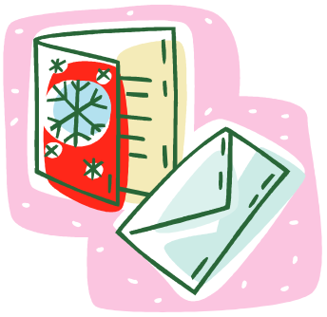
Work Card
'Supermodel' © Copyright 2001 S & J Shipway
£
Work Card
'Supermodel' © Copyright 2001 S & J Shipway
£
Work Card
'Supermodel' © Copyright 2001 S & J Shipway
£
Work Card
'Supermodel' © Copyright 2001 S & J Shipway
Greeting Card Photo
£10,000
Work Card
'Supermodel' © Copyright 2001 S & J Shipway
£
Work Card
'Supermodel' © Copyright 2001 S & J Shipway
£
Work Card
'Supermodel' © Copyright 2001 S & J Shipway
£
Work Card
'Supermodel' © Copyright 2001 S & J Shipway
£
Work Card
'Supermodel' © Copyright 2001 S & J Shipway
£
Work Card
'Supermodel' © Copyright 2001 S & J Shipway
‘Clothes for the larger lady’ catalogue
£20,000
Weight
>6
Largest model wins contract !

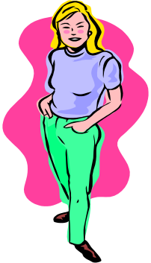

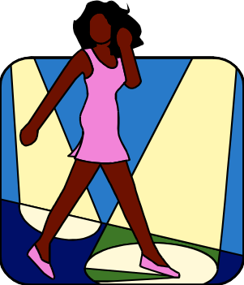




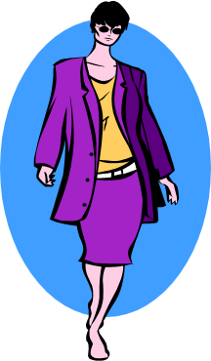
Work Card
'Supermodel' © Copyright 2001 S & J Shipway
Catalogue Work
£2,000
Work Card
'Supermodel' © Copyright 2001 S & J Shipway
Cosmetics Shoot
£10,000
Work Card
'Supermodel' © Copyright 2001 S & J Shipway
Paris Fashion Show
£50,000
Work Card
'Supermodel' © Copyright 2001 S & J Shipway
Television Bit-part
£20,000
Work Card
'Supermodel' © Copyright 2001 S & J Shipway
Publicity Shoot
£15,000
Work Card
'Supermodel' © Copyright 2001 S & J Shipway
Fashion Shoot
£15,000
Work Card
'Supermodel' © Copyright 2001 S & J Shipway
Sleazy Tabloid Photo
£1,000
Work Card
'Supermodel' © Copyright 2001 S & J Shipway
Soap Opera Part
£25,000
Work Card
'Supermodel' © Copyright 2001 S & J Shipway
Shop Opening
£10,000
Work Card
'Supermodel' © Copyright 2001 S & J Shipway
Cover Girl Photo
£2,000


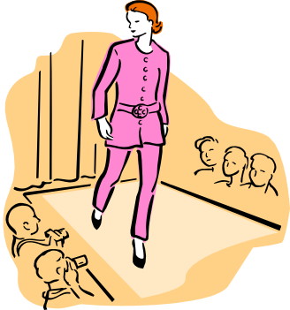



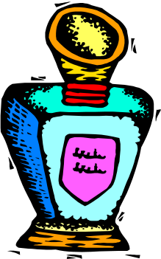
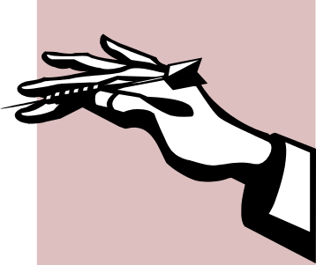

Work Card
'Supermodel' © Copyright 2001 S & J Shipway
Health
-2
Cigarette Commercial
£25,000
Work Card
'Supermodel' © Copyright 2001 S & J Shipway
Bond Girl
£20,000
Work Card
'Supermodel' © Copyright 2001 S & J Shipway
Dating a politician
£20,000
Work Card
'Supermodel' © Copyright 2001 S & J Shipway
Hand Modelling
£1,000
Work Card
'Supermodel' © Copyright 2001 S & J Shipway
Perfume Advert
£20,000
Work Card
'Supermodel' © Copyright 2001 S & J Shipway
Diet food endorsement
£20,000
Weight
<6
Work Card
'Supermodel' © Copyright 2001 S & J Shipway
Birmingham Fashion Show
£5,000
Work Card
'Supermodel' © Copyright 2001 S & J Shipway
Shoe Show
£10,000
Work Card
'Supermodel' © Copyright 2001 S & J Shipway
Product Launch
£20,000
Work Card
'Supermodel' © Copyright 2001 S & J Shipway
Cosmetics Shoot
£10,000
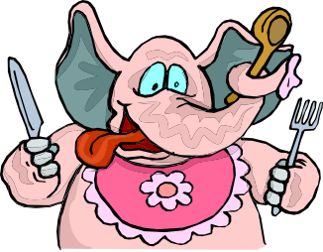
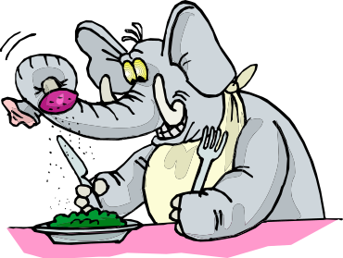

Event
'Supermodel' © Copyright 2001 S & J Shipway
Bad Hair Day
Looks
-1
Event
'Supermodel' © Copyright 2001 S & J Shipway
Dumped!
Looks
-1
Event
'Supermodel' © Copyright 2001 S & J Shipway
Binge!
Eat all the food in your hand immediately. May be countered by a Chunder card.
Event
'Supermodel' © Copyright 2001 S & J Shipway
Come to Lunch
Play in conjunction with a food card. Force player to eat the food immediately. May be countered by a Chunder card.
Event
'Supermodel' © Copyright 2001 S & J Shipway
Binge!
Eat all the food in your hand immediately. May be countered by a Chunder card.
Event
'Supermodel' © Copyright 2001 S & J Shipway
Come to Lunch
Play in conjunction with a food card. Force player to eat the food immediately. May be countered by a Chunder card.
Event
'Supermodel' © Copyright 2001 S & J Shipway
Bad Publicity
Looks
-1
Event
'Supermodel' © Copyright 2001 S & J Shipway
Zit Attack!
Looks
-1
Event
'Supermodel' © Copyright 2001 S & J Shipway
New Shoes
Looks
+1
Event
'Supermodel' © Copyright 2001 S & J Shipway
Break Nail
Looks
-1


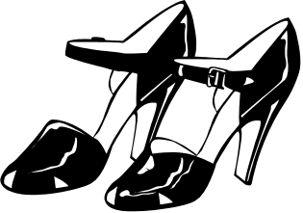
Looks
-1
Event
'Supermodel' © Copyright 2001 S & J Shipway
Botched Facelift
Permanent
Keep this card in front of you for the rest of the game.
Event
'Supermodel' © Copyright 2001 S & J Shipway
Binge!
Eat all the food in your hand immediately. May be countered by a Chunder card.
Event
'Supermodel' © Copyright 2001 S & J Shipway
Zit Attack!
Looks
-1
Event
'Supermodel' © Copyright 2001 S & J Shipway
Bad Hair Day
Looks
-1
Event
'Supermodel' © Copyright 2001 S & J Shipway
New Hairdo
Looks
+1
Event
'Supermodel' © Copyright 2001 S & J Shipway
New Dress
Looks
+1
Event
'Supermodel' © Copyright 2001 S & J Shipway
Catch a Cold
Looks
-1
Looks
+1
Event
'Supermodel' © Copyright 2001 S & J Shipway
Boob Job
Permanent
Keep this card in front of you for the rest of the game.
Event
'Supermodel' © Copyright 2001 S & J Shipway
Come to Lunch
Play in conjunction with a food card. Force player to eat the food immediately. May be countered by a Chunder card.
Event
'Supermodel' © Copyright 2001 S & J Shipway
Embarrassing Photos
Looks
-1

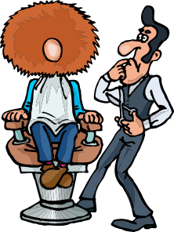

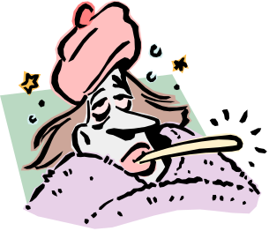


Supermodel

A card game for 2-4 players

The Game
In this game you play the part of a beautiful Supermodel, who is fighting with her colleagues to win lucrative modelling contracts. You have to keep yourself as skinny as possible – but try not to die of anorexia, or get so thin you disappear altogether!

Playing Pieces
The following pieces are required to play the Supermodel game:
20 ‘Work’ cards
72 Game cards (‘Food’, ‘Activity’, ‘Event’ and ‘Chunder’)
Approx. 30 counters per player for Weight and Health.

Preparation
Before you start to play, you need to do the following:

- Separate out the ‘Work’ cards from the rest of the deck. Shuffle these, and place them face-down in the middle of the table.
- Shuffle the remaining cards. Deal 4 cards to each player, and place the remaining cards face-down in the middle. This is where you will draw new cards from.
- Give each player 5 (five) counters to represent their health. These are put on the table in front of the player.
- Give each player 10 (ten) counters to represent their weight. These are put on the table in front of the player. We suggest that you use different colours of counter to represent Weight and Health, so as not to confuse them.
- Each player looks at her cards. The top ‘Work’ card is turned over, to reveal the first contract to be played for.
- The most beautiful player starts. If there is debate as to who this is, then start with the player to the left of the dealer!

Game Play
Each round starts with the player who won the last round, and continues clockwise until all players have played. At the start of each round, players can opt to skip the round or retire. At the end of the round, the contract is awarded to the skinniest player (subject to any modifiers in play).

Progression of a round of play
- Players can opt to ‘take a holiday’ (miss the round altogether) or to ‘retire’ (stop playing, but keep all money gathered so far).
- The top ‘Work’ card is turned over to reveal the next contract to compete for.
- The player who won the last contract goes first, and play then progresses in a clockwise direction until all players have played.
- The contract is awarded to the winning player. If all players refuse a contract, the card is discarded, and the same player that started the current round starts the next round.
- All non-permanent Event cards in force are discarded.
- If there are no contract cards remaining, then the game is over!

Each player takes her turn sequentially. If, at the end of the turn, the player has zero health then they are dead from anorexia. Any work cards they have previously won are discarded – money’s no use when you are dead! Similarly, if they have zero weight at the end of the turn, they have become so skinny that they have vanished altogether. Again, any work cards are discarded and they are out of the game.
Note that if their Health is less than 4 they are too ill to work, and are unable to compete for the current contract.

Winning a Contract
Whichever player is the thinnest wins the contract, provided they meet any special criteria. If there are any Event cards in play, then these should be used to modify the players’ ‘effective’ weights when making the comparison.
Players with less than 4 health cannot win a contract. In the event of a tie, the healthiest of the players wins. In the event of the contest still being tied, then the youngest player wins. If noone will reveal her true age, then the contract remains on the table and noone gets it. Note that you can refuse a contract if you do not want it. If all players refuse the contract, then it is discarded.

Progression of a turn
- The player loses one Weight point.
- The player may optionally draw up to three new cards from the game deck. She does not have to draw any if she does not want to.
- The player may play one or more of her cards, in any sequence. ‘Event’ cards may be played against any player (who may immediately respond to Binge/Lunch with a ‘Chunder’ card, if she wishes).
- Next, the player may optionally discard one card from her hand onto the discard pile.
- If the player’s weight is 5 or less, then she loses a health point. If her weight is 2 or less, then she loses a second health point.
- If the player’s weight is zero, or her health is zero, then she is dead. All her Work cards are discarded and she is out of the game, and may now sulk until the other players have finished.

Food Cards
All food cards have two modifiers – ‘Weight’ and ‘Health’. When a player plays a Food card, she gains or loses Weight and Health as indicated, unless she immediately plays a ‘Chunder’ card (and therefore throws up the food immediately). If a player is hit with a ‘Binge’ card, then all Food cards in her hand have to be played immediately. No other cards (apart from ‘Chunder’) may be played at this time.

Activity Cards
Activity cards are similar to food cards, in that they have a Weight and Health modifier, and this takes effect when the card is played. However, they are not played when hit by a ‘Binge’ card. Activity cards tend to lower weight, and raise health.

Event Cards
Event cards may only be played during your own turn. Most Event cards have an effect only on that round of play, and give either a bonus or penalty to the player on whom they were played when calculating the winner of the contract.
Some of the Event cards, however, are marked ‘Permanent’, and these are kept in effect for the rest of the game.
The ‘Binge’ and ‘Come to Lunch’ Events are special – these are described below.

‘Binge’ Cards
A Binge card is played against another player. When you hit a player with a ‘Binge’, she must immediately eat all her food (i.e., play all the food cards in her hand). She has the option to play a ‘Chunder’ to counter the effects of the Binge, but the Food cards are still discarded. If her health or weight reach zero as a result of this, then she is out of the game immediately. Note that a ‘Binge’ card may not be played on a player who is on Holiday.

‘Come to Lunch’ Cards
Similar to Binge cards, these are played together with a Food card, and force the victim to eat the item of food (and suffer all gains and penalties), unless countered with a Chunder card. As with a ‘Binge’, this may not be played on a player who is on Holiday.

Chunder Cards
A Chunder card negates the effect of all Food cards played previously. Although you can play a Chunder card during normal play (for example, to discard many Food cards in your hand at once), its main use is to counter the effects of a Binge card. Note that it costs you one health point to play a Chunder card, and if this drops your health to zero then you die immediately. Ha.

Work Cards
Work cards are all marked with a value. At the end of the game, all players still living total their collected Work cards to find the winner. Note that some Work cards (‘Slim plan endorsement’ and ‘Clothes for the larger lady’) have restrictions on the weight of who is allowed to win them. Also, some (‘Cigarette Commercial’) have a Health point cost for whoever wins them.
If you win a work card, you do not have to take it (for example, you may not want to Health point penalty).
If no-one wants, or is eligible for a Work card, then it is discarded. In the event of an unbreakable tie, the card remains on the table for another hand.

Health
Health starts at 5, and has a maximum of 10. If it reaches 0 at the end of your turn, you are dead from anorexia and out of the game. Also, if it reaches 3 or less, you are unable to work and cannot compete for contracts.

Weight
Your weight starts off at 10, and has no maximum. However, if it falls below 6 then you take a penalty of one health point at the end of your turn. If it is below 3 then this penalty is increased to 2. If your weight drops to zero (unlikely!) then you are so underweight that you die of malnutrition.

Taking a Holiday
At the beginning of each round, before the Work card is turned over, each player can opt to take a holiday. When in Holiday mode, you do not play your turn as normal, and instead receive two points to allocate either to your health or to your weight, as you see fit. When on Holiday, you cannot Work (obviously), and you also cannot be hit by an ‘Event’ card. You may not play any cards yourself. You also do not lose the normal one weight point as you would on a normal turn. Finally, you are allowed to (optionally) draw a single card, and (optionally) discard a single card.

Retirement
At any point, a player may choose to retire. In this case, she keeps her current total of earnings, and leaves the game until the end. At this point, her total is compared with that of the other players in the same way as it would be had she continued playing.

Winning the game
To win the game, you have to be alive at the end (obviously). The winner is the player who has the most money when the value of her accumulated Work cards are totalled.

Two Player Game
In the two player version, you do not award the contract to the youngest player in the event of a tie on weight and health. This gives too much of an unfair advantage! Just leave the work card on the table and play for it again – or discard it if neither of you want the contract.

Four Player Game
In the four player game, you may wish to remove the ‘Paris Fashion Show’ work card (£50,000) as it can skew the scores too much.

More than Four Players
By merging two sets of cards, you can make a new, larger pack for a 5-8 player game. Remove the £50,000 Contract cards in the 8 player game.

Variations
In order to change the game, there are a number of variations to the rules you might like to try.
- Remove some of the higher scoring work cards – such as the ones with weight restrictions, and the £50,000 Paris show. Do this is the game appears to take too long.
- Create your own food and exercise cards
- Allow players to discard two cards, instead of just one. Do this if you end up with huge hands, and vast weights when hit by a ‘binge’.

Strategies
There are several strategies that you may like to consider while playing Supermodel.
- If you are holding a lot of cards, do not draw too many in case you are caught by a ‘Binge’ card with a large amount of food and no ‘Chunder’ card.
- When a low value contract is up, use the time to recover some health, and raise your weight to safe limits. Then, when a high value contract appears, starve yourself to get it.
- The person who won the last contract is at a disadvantage on the current one, so, don’t always try to win on low-value contracts.
- Save a ‘Binge’ card (or other ‘Event’ cards) to sabotage the competition when playing for a high-value contract.
- Try to keep your health up to at least 5 at all times.
- When the end of the game is approaching, go for ultimate skinniness. Hopefully the game will end before you die.

Note
This game is Copyright 2001 and 2002, Steve and Jenny Shipway. All rights reserved.
This game should not be viewed as a source of nutritional or dietary advice, nor should it be seen to encourage excessive skinniness. Just because the contracts go to the thinnest doesn’t mean that this is right. Have some common sense. If you are worried you may have an eating disorder, please consult your doctor or dietician for advice.
Anyone who uses a silly card game as a source of lifestyle advice is in need of some psychiatric help, as well!

For more details of the Supermodel game, and other fine games and software, visit the website at http://www.cheshire.demon.co.uk/supermodel

